MEMORANDUM

TO: Tyke Redfearn, PE Design Build Program Manager

FROM: State Pavement Design Engineer Thompson
Assistant State Pavement Design Engineer Carroll

DATE: January 29, 2017

RE: US 21 over Harbor River

On the day of December 13 2016, OMR collected 7 cores and conducted Falling Weight Deflectometer (FWD) testing on a half mile section before and after the bridge on US 21 over Harbor River. This was done in order to assess the current condition of the pavement and make recommendations for pavement rehabilitation. All of the cores were taken from the or near the right wheel path of the mainline. The following is a summary of our observations from these cores.

US 21
Mainline:
The depth of asphalt averages 12.3 inches ranging from 11.5 to 13.0 inches and has an existing structural number of 4.24. The 20 year design requires a SN of 4.17.

The surface conditions of the pavement are as follows. The pavement surface is relatively good condition with little to no surface distresses present. None of the cores exhibits bottom up cracking.

In general the mixtures are in relatively good condition. The majority of the cores have at least 6 inches of dense graded asphalt over a sand asphalt base consisting of mainline limestone. The sand asphalt base appears to have a high voids content throughout the mixture however this seems to be related to the original gradation of the mixture and poor compaction instead of stripping. Reference pictures of locations #3 and #5 for a representation of typical pavement cross section and variations in mixture quality.

Attachments:

Core #3
Core #5

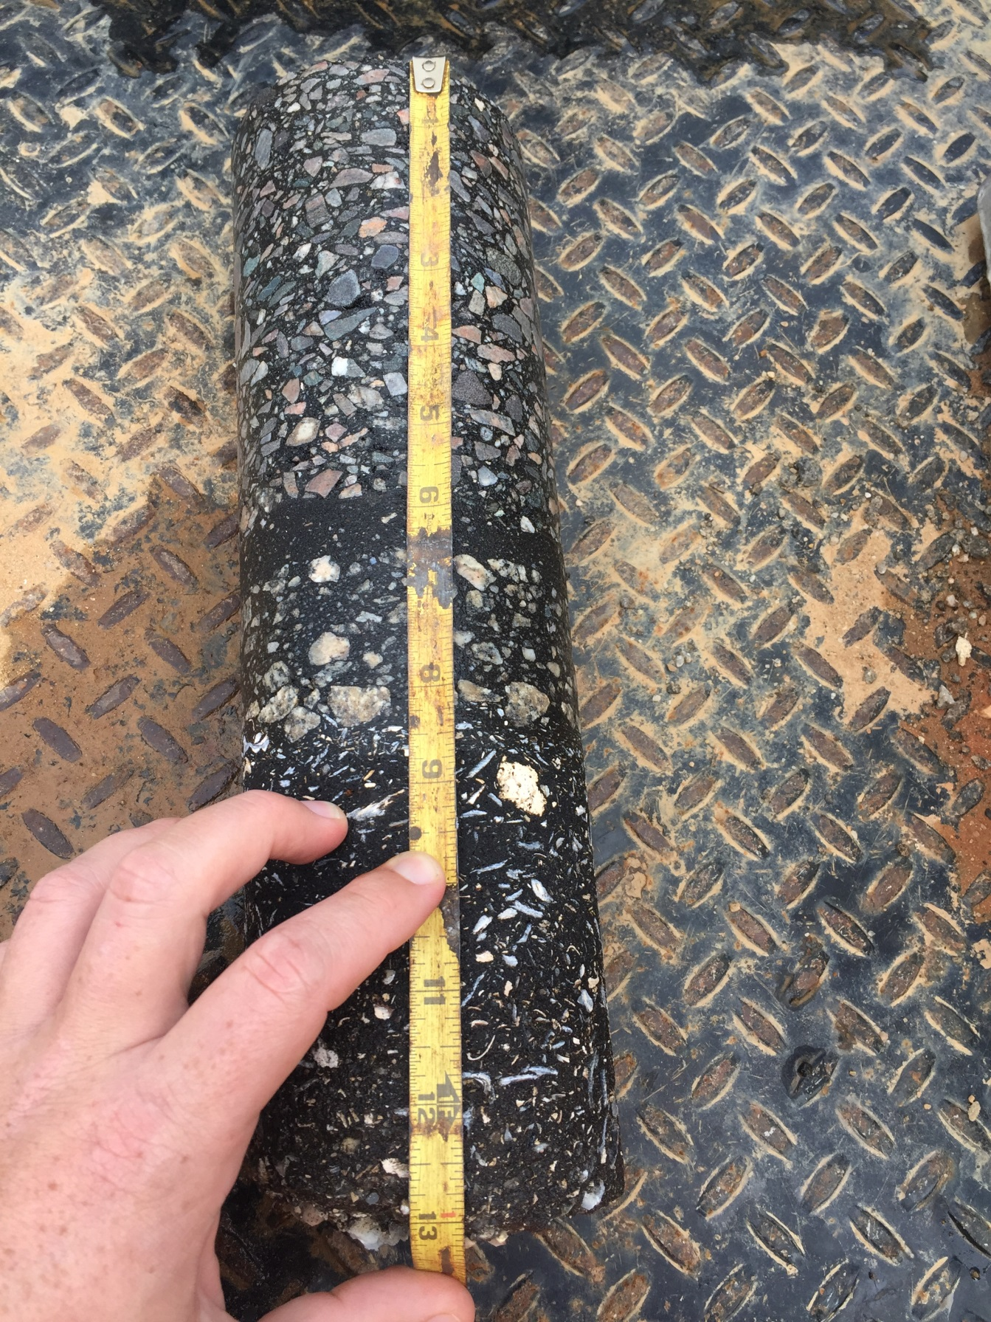
Core # 3

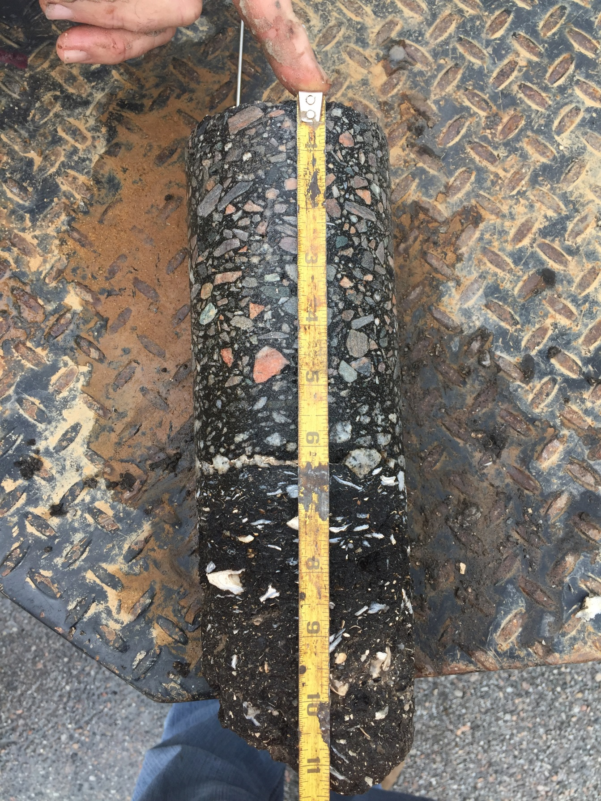
Core #5

